**JMP BIRTHDAY SIGN**

**CELEBRATE YOUR CHILDREN’S BIRTHDAY IN LIGHTS**!

***MCj04126760000[1]***Children love having friends and families wish them a happy birthday! Think of how happy they will be to see their name on the JMP sign as they arrive at school.

As a fundraiser, the JMP PTO will be putting children’s birthdays on the sign outside of the school for a fee of **$15**. Therefore, availability is limited, so send in your forms to reserve your space

Please note that **birthday announcements** **are placed on the side of the sign facing JMP school.** The other side of the sign facing the First Aid squad is for school announcements. Only the children’s first name, followed by the first initial of their last name, will be placed on the sign. Due to the limited space on the sign, if your child has a nickname and you would like to display the nickname, please indicate below. Please give us **at least** a 2 week notice if you would like your child's name on the JMP Birthday sign.

*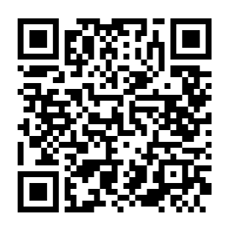***Two easy ways to participate in the JMP Birthday Sign Fundraiser:**

1. *Venmo:* Please complete the form below and return it to the school and submit your payment via Venmo. On Venmo search “JMP-PTO” or scan the QR CODE and include your **child's name/teacher/section + birthday + ‘JMP Birthday Sign’** in the memo box.
2. *Cash/Check:* Please complete the form below and return it to the school in an envelope marked **‘JMP Birthday Sign’** with your payment in cash (exact change) or make the check payable to JMP PTO.

All proceeds help fund PTO-sponsored student activities/events. Thanks for your participation!

Regards,

JMP PTO Executive Board l Questions? Email us: [jmppto@gmail.com](mailto:jmppto@gmail.com)

✂-----------------------------------------------------------------------------------------------------------------------

# **JMP Birthday Sign**

Student’s name: ______

First Name (or Nickname) Last Name

Student’s teacher/grade: ________________________________

Birthday (month/day): /

Parent’s name: ____________________________ Parent’s phone number: ________________

Parent’s signature:

Payment type: Venmo Cash Check # __________